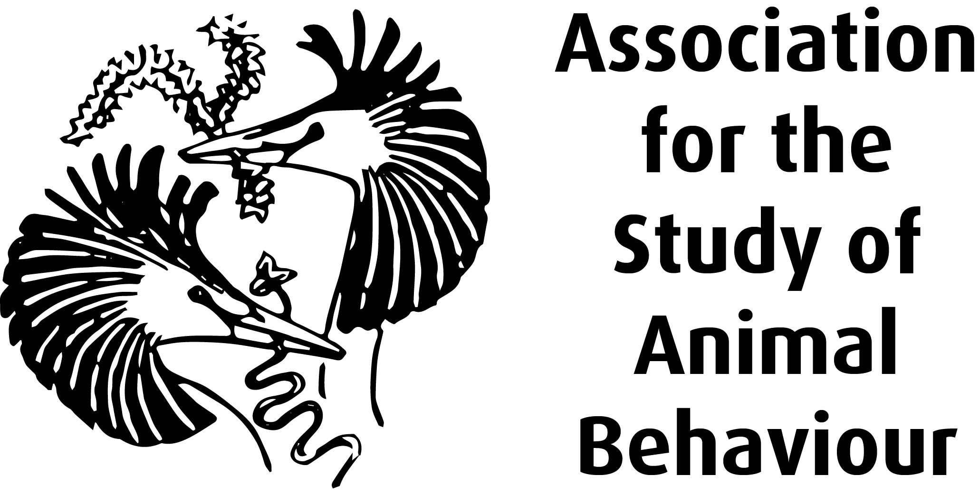

Aim
To test if benzoquinones from millipedes deter mosquitoes
To evaluate if benzoquinones elicit self anointing in wedge- shaped capuchin monkeys.

Methods
Laboratory reared female yellow fever mosquitoes were presented with serial dilutions (0.025M, 0.05M, 0.1M, 0.2M, 0.4M) of two synthetic analogues (2-methyl-1, 4-benzoquinone {toluquinone} and 2-methoxy-3-methyl-1, 4-benzoquinone {MMB}) of millipede secretory compounds or acetone (control) on nylon-reinforced silicone membranes placed over wells containing human blood.
Under laboratory conditions C.apella and C. capucinus were presented with filter papers containing 0.1M solutions of toluquinone or MMB in acetone, or acetone.
Results
Mosquitoes had fewer contact landings, fed less frequently and flew more frequently in the presence of toluquinone and MMB in comparison to control. Exposure to filter papers containing benzoquinones led to rubbing of fur, feet and tail. Self-anointing was not observed with control filter paper.
Discussion and Conclusion
The researchers state that their results support the suggestion made by Valderrama et al. (2000) that benzoquinone compounds applied to the fur act as chemical deterrents against some arthropods. They state that many factors such as quantity of deterrent elicited from the millipedes the capuchins encounter remain to be assessed. Weldon et al. suggest that further studies are needed on self-anointing in other vertebrates.

